Basic Concept：
a：The most primitive processing method, the current energy of the system meets the operation of each layer of ReRam full power consumption.
b：Parallel operation when system energy meets multiple layers of ReRam in the current layer.
c：Tile the ReRam and let the ReRam part start when the energy is not enough to run at full power, thus reducing the power consumption requirement, enabling the system to run in low energy state and running in parallel.
d：Pipeline is introduced on the basis of c, and multiple convolutional layers of ReRam are run together when the energy consumption is satisfied, thereby improving work efficiency.

Operating Procedures：
a_solution
Implementation process：
- Enter the number of layers of convolution
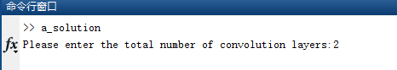
- Enter the corresponding layer m n values separately
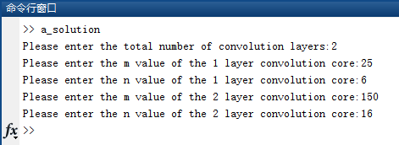
- Get the output data matrix ‘out’
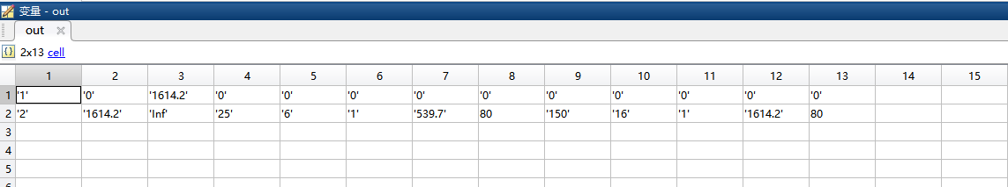
As shown in the figure, the data in the obtained matrix out is the required form.
Each column parameter is:
1 | 2 | 3 | 4 | 5 | 6 | 7 | 8 | 9 | 10 | 11 | 12 | 13
energy level | Lower bound | Upper Bound | L1  m | L1  n | L1  aG | L1  energy | L2  latency | L2  m | L2  n | L2  aG | L2  energy | L2  latency

b_solution
Implementation process：
- Enter the number of layers of convolution
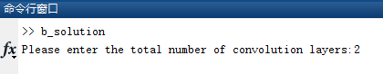
2. Enter the corresponding layer m n values separately

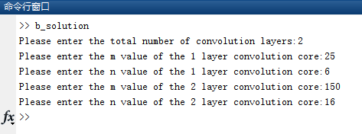
3. Get the output data matrix ‘out’
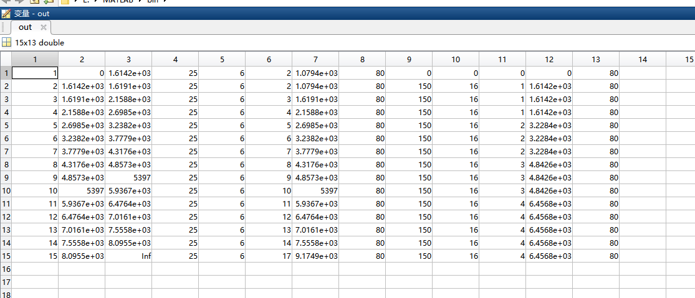
As shown in the figure, the data in the obtained matrix out is the required form.
Each column parameter is:
1 | 2 | 3 | 4 | 5 | 6 | 7 | 8 | 9 | 10 | 11 | 12 | 13
energy level | Lower bound | Upper Bound | L1  m | L1  n | L1  aG | L1  energy | L2  latency | L2  m | L2  n | L2  aG | L2  energy | L2  latency

C_solution
Implementation process：
1. Enter the number of layers of convolution
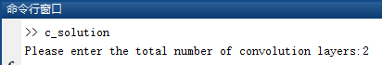
2. Enter the corresponding layer m n values separately
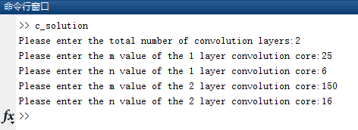
3. Get the output data matrix ‘out_merge’

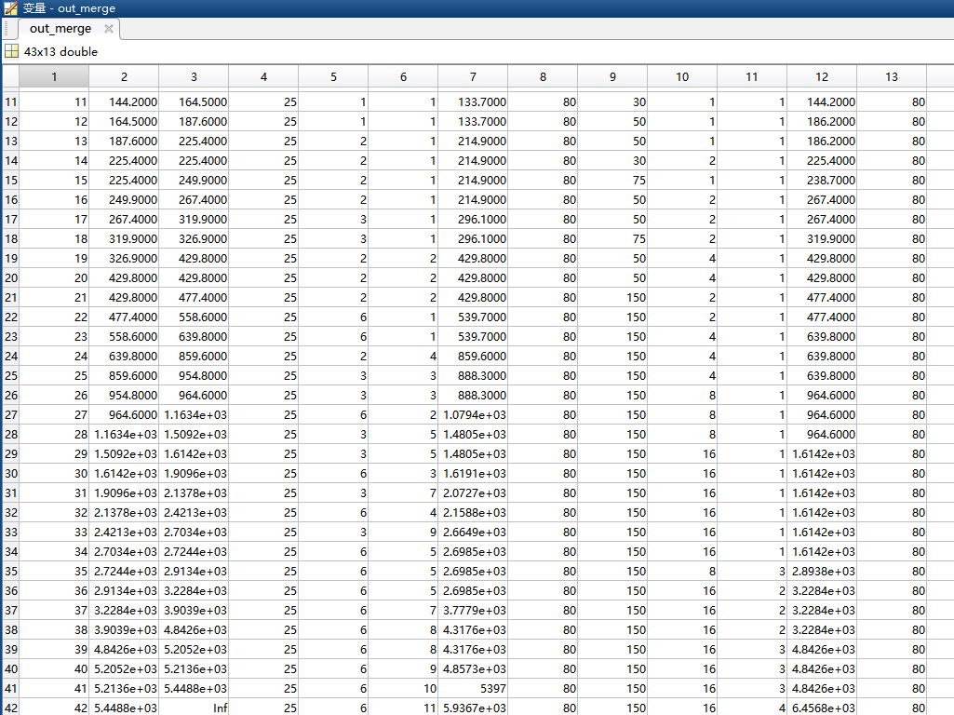

As shown in the figure, the data in the obtained matrix out is the required form.
Each column parameter is:
1 | 2 | 3 | 4 | 5 | 6 | 7 | 8 | 9 | 10 | 11 | 12 | 13
energy level | Lower bound | Upper Bound | L1  m | L1  n | L1  aG | L1  energy | L2  latency | L2  m | L2  n | L2  aG | L2  energy | L2  latency

d_solution

Implementation process：
1. Enter the number of layers of convolution
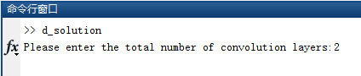
2. Enter the corresponding layer m n values separately
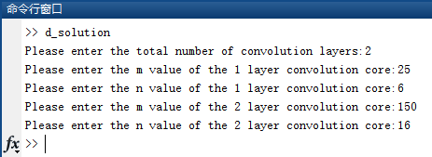
3. Get the output data matrix ‘out_merge’
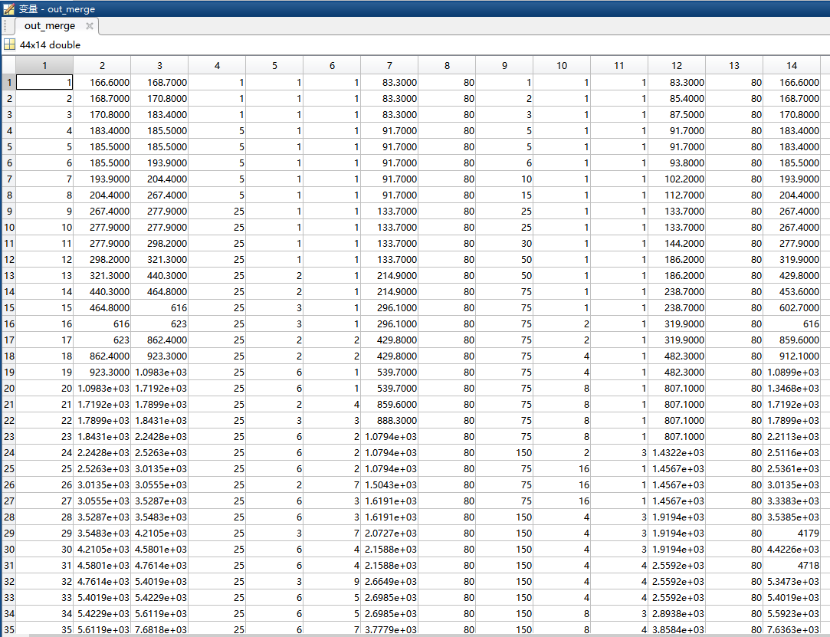

1 | 2 | 3 | 4 | 5 | 6 | 7 | 8 | 9 | 10 | 11 | 12 | 13 | 14
energy level | Lower bound | Upper Bound | L1m | L1n | L1  aG | L1  energy | L2  latency | L2  m | L2  n | L2  aG | L2  energy | L2  latency | Sum of energy

Program parameter modification:
Modifications to the aG maximum (G) for different layers at different energies are on line 25 of the program. As shown in the figure below, AG is an array that stores G values of each layer, and can be manually modified when switching.
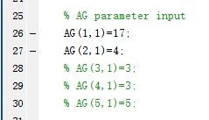
Output Format：
After each program, there is a statement corresponding to the output of the excel file. For example, the output statement in the a program is: xlswrite('a.xls',out,1,'A2'),the output format of the remaining programs is also the xls file.

